MODEL PRACTICAL EXAM

1)MULTIPLICATION TABLE

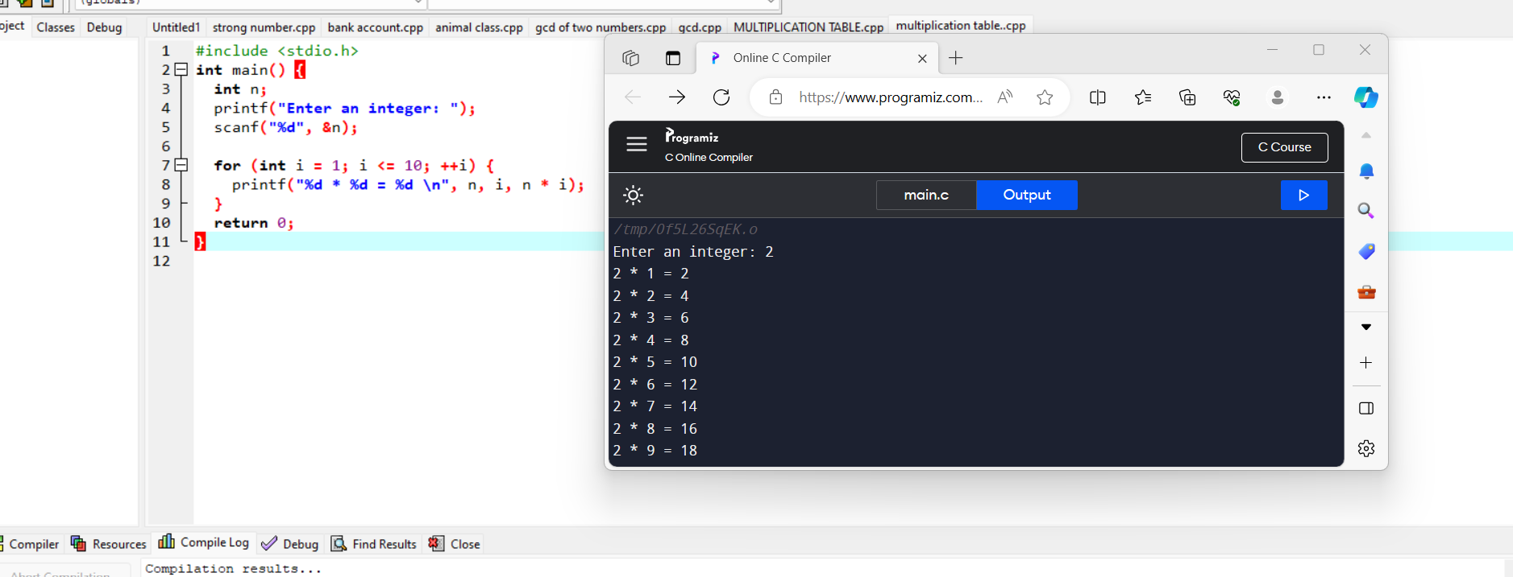

2)STRONG NUMBER

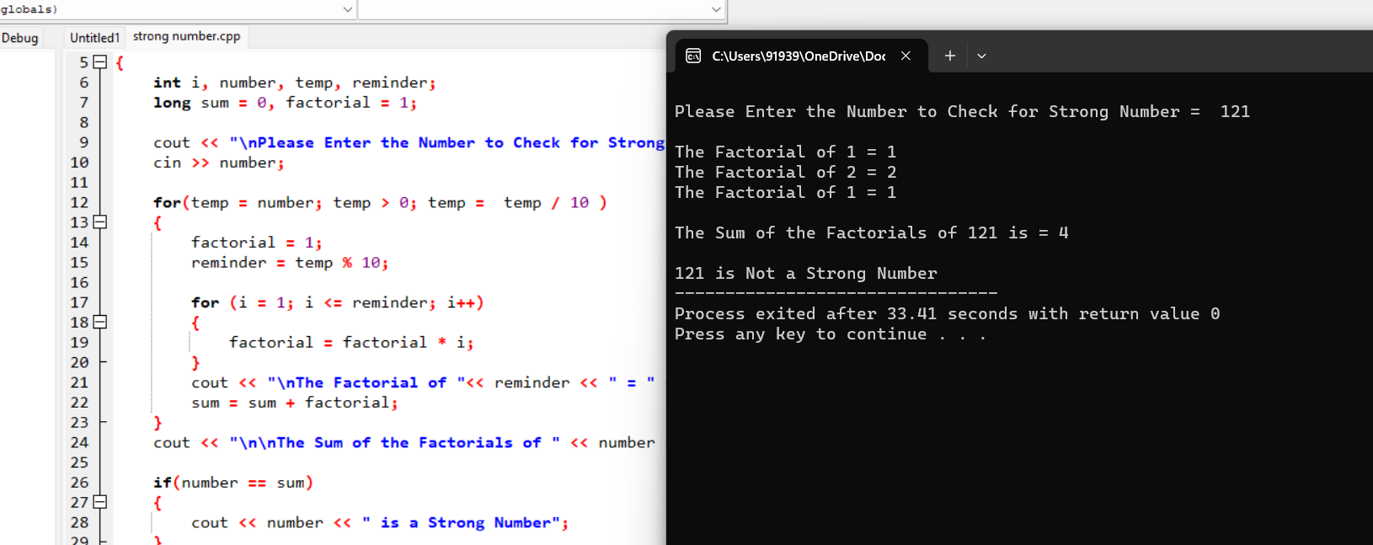

3)PATTERN

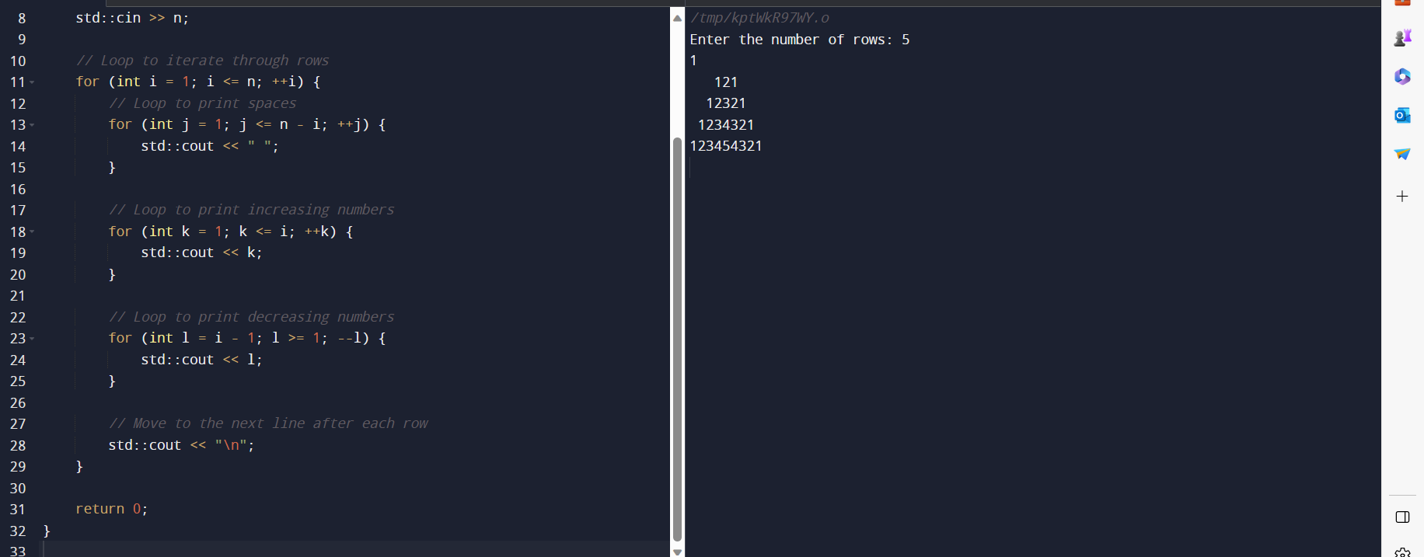

4)GCD

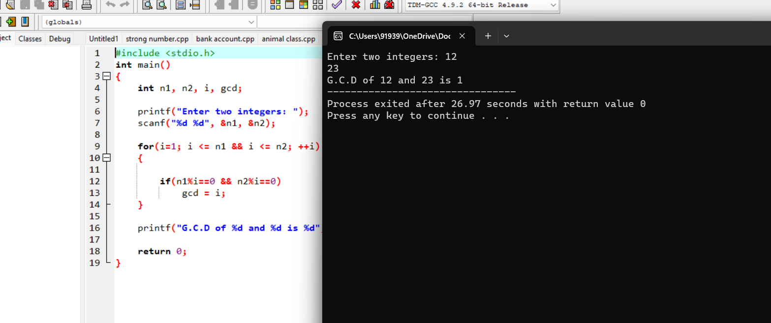

5)CLACULATE PAY OF EMPLOYEE

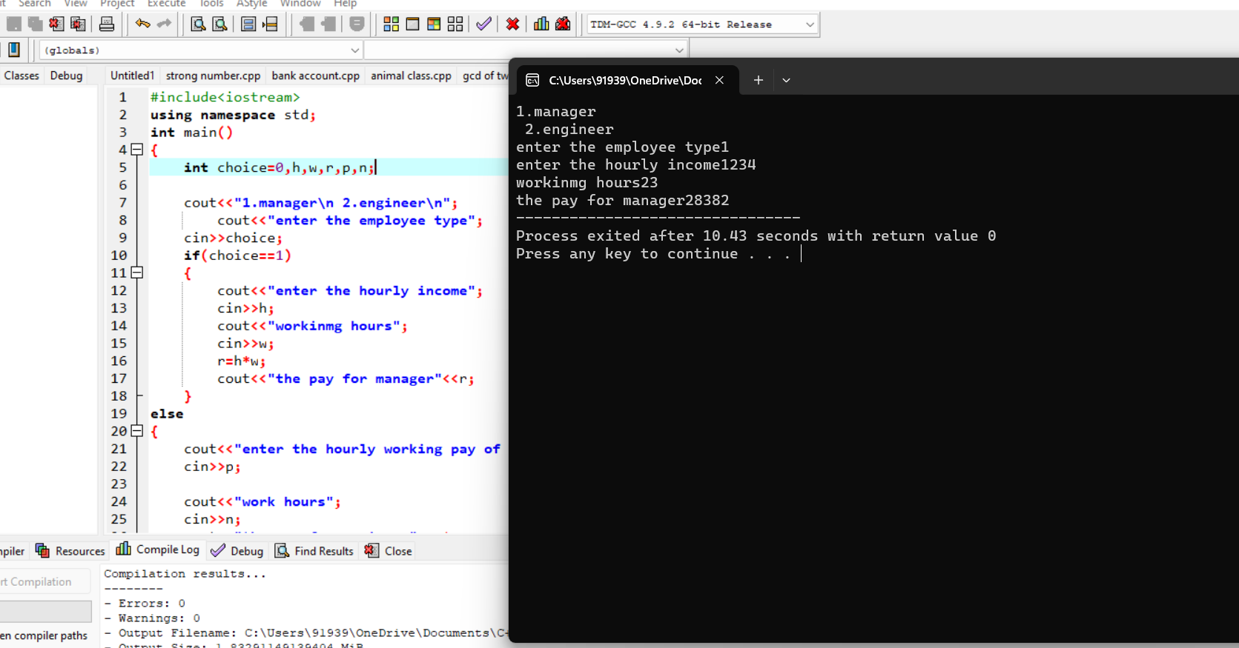

6)ANIMAL CLASS

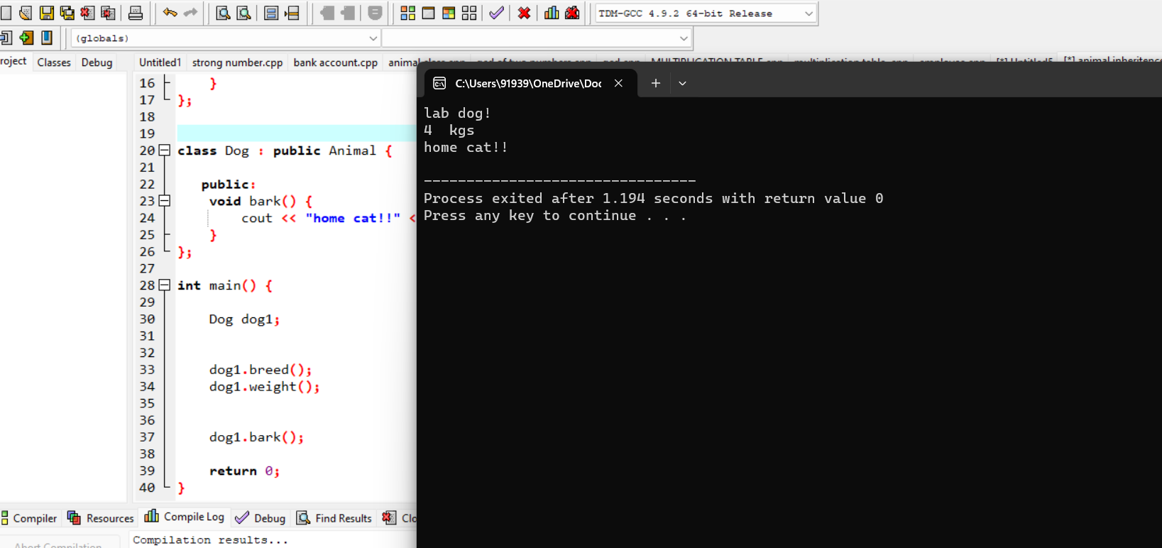

7)INTEGER ARRAY ,DOUBLE ARRAY ,CHARACTER ARRAY

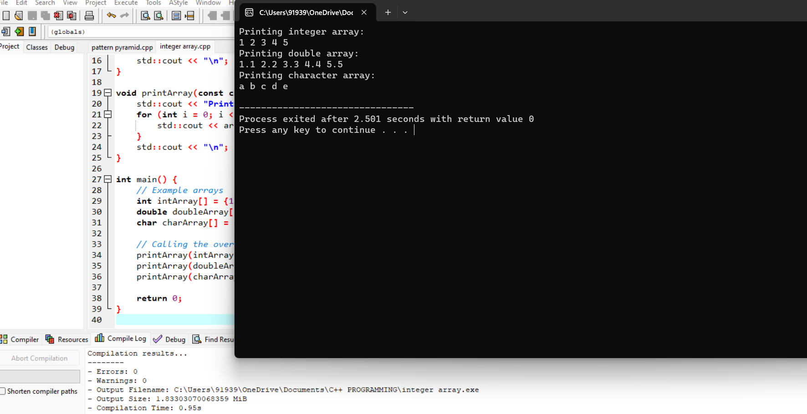

8) BANK ACCOUNT

